TASK 10

1.Coding:

2.Coding :

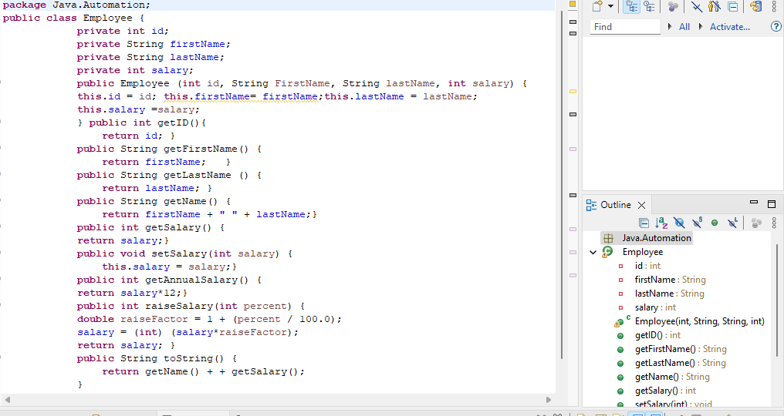

3.Coding:

4.Coding:

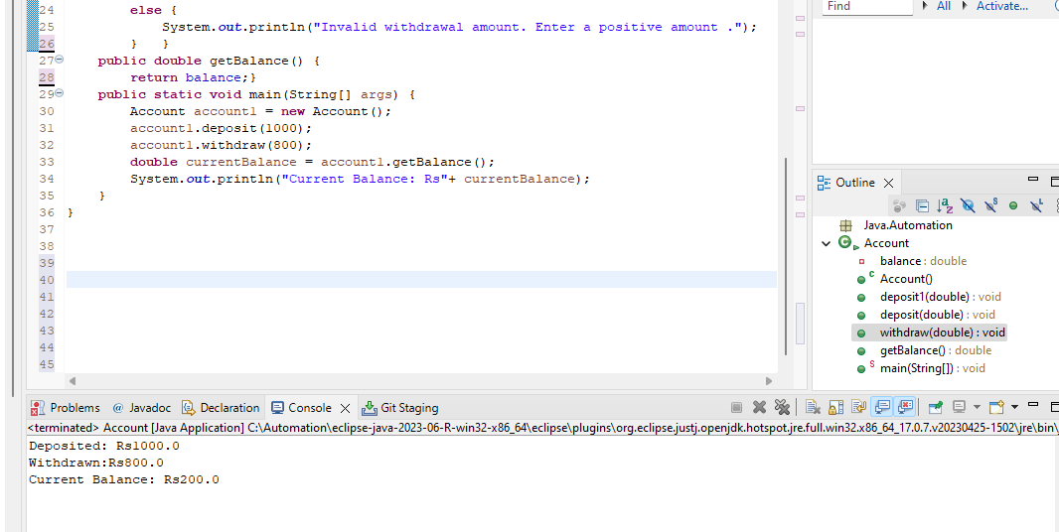

5.Coding:

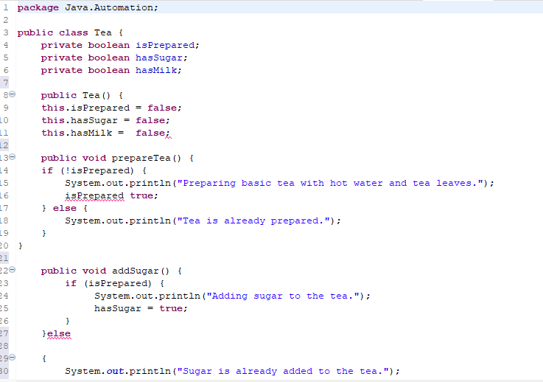

6.Coding:

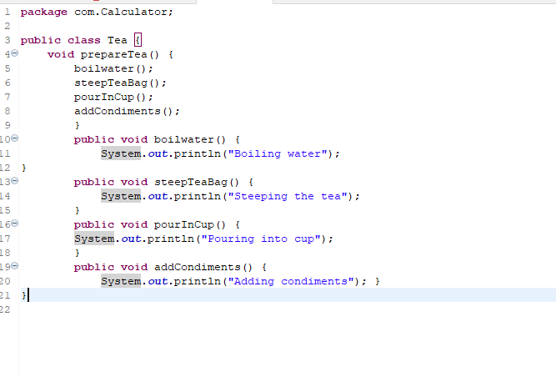

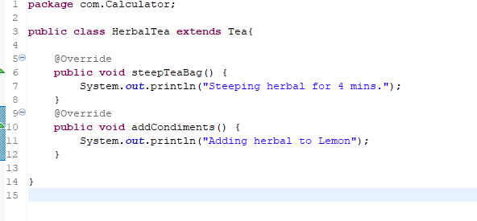

7.Coding:



